A Title is Fewest Possible Words, Accurately Describe the Content
MAKSIMAL
12 HALAMAN
(Center, TNR 24)

First Author¹, Second Author², Third Author³
¹Institution/affiliation
addres, telp/fax of institution/affiliation
^{2,3}Institution/affiliation
addres, telp/fax of institution/affiliation
xxxx@xxxx.xxx¹, yyyy@yyyy.yyy², zzzz@zzzz.zzz³

Abstract – A well-prepared abstract enables the reader to identify the basic content of a document quickly and accurately, to determine its relevance to their interests, and thus to decide whether to read the document in its entirety. The Abstract should be informative and completely self-explanatory, provide a clear statement of the problem, the proposed approach or solution, and point out major findings and conclusions. The Abstract should be 100 to 150 words in length. The abstract should be written in the past tense. Standard nomenclature should be used and abbreviations should be avoided. No literature should be cited. The keyword list provides the opportunity to add keywords, used by the indexing and abstracting services, in addition to those already present in the title. Judicious use of keywords may increase the ease with which interested parties can locate our article. *CRITICAL: Do Not Use Symbols, Special Characters, or Math in Paper Title or Abstract.

Keywords: maximum 5 keywords from paper

1. Introduction
The main text format consists of a flat left-right columns on A4 paper. The margin text from the left, right, top, and bottom 3 cm. The manuscript is written in Indonesian. The manuscript is written in Microsoft Word, single space, TNR 11pt, minimum 8 pages and maximum 12 pages, which can be downloaded at the website: http://telka.ee.uinsgd.ac.id
A title of article should be the fewest possible words that accurately describe the content of the paper. Omit all waste words such as "A study of ...", "Investigations of ...", "Implementation of ...”, "Observations on ...", "Effect of.....", “Analysis of …”, “Design of…” etc. Indexing and abstracting services depend on the accuracy of the title, extracting from it keywords useful in cross-referencing and computer searching. An improperly titled paper may never reach the audience for which it was intended, so be specific [1-4].
The Introduction should provide a clear background, a clear statement of the problem, the relevant literature on the subject, the proposed approach or solution, and the new value of research which it is innovation. It should be understandable to colleagues from a broad range of scientific disciplines [5].
Organization and citation of the bibliography are made in Vancouver style in sign [6, 7] and so on. The terms in foreign languages are written italic (italic). Authors are suggested to present their articles in the section structure: Introduction - The Proposed Method/Algorithm (optional) - Research Method - Results and Discussion – Conclusion [8-11].
Literature review that has been done author used in the chapter "Introduction" to explain the difference of the manuscript with other papers, that it is innovative, it are used in the chapter "Research Method" to describe the step of research and used in the chapter "Results and Discussion" to support the analysis of the results [2]. If the manuscript was written really have high originality, which proposed a new method or algorithm, the additional chapter after the "Introduction" chapter and before the "Research Method" chapter can be added to explain briefly the proposed method or algorithm [9-11].

2. Research Method
Explaining research chronological, including research design, research procedure (in the form of algorithms, Pseudocode or other), how to test and data acquisition [1], [3]. The description of the course of research should be supported references, so the explanation can be accepted scientifically [2], [4].
Tables and Figures are presented center, as shown below and cited in the manuscript.

Table 1. The Performance of ...  Variable Speed (rpm) Power (kW)  X 10 8.6  Y 15 12.4  Z 20 15.3 | 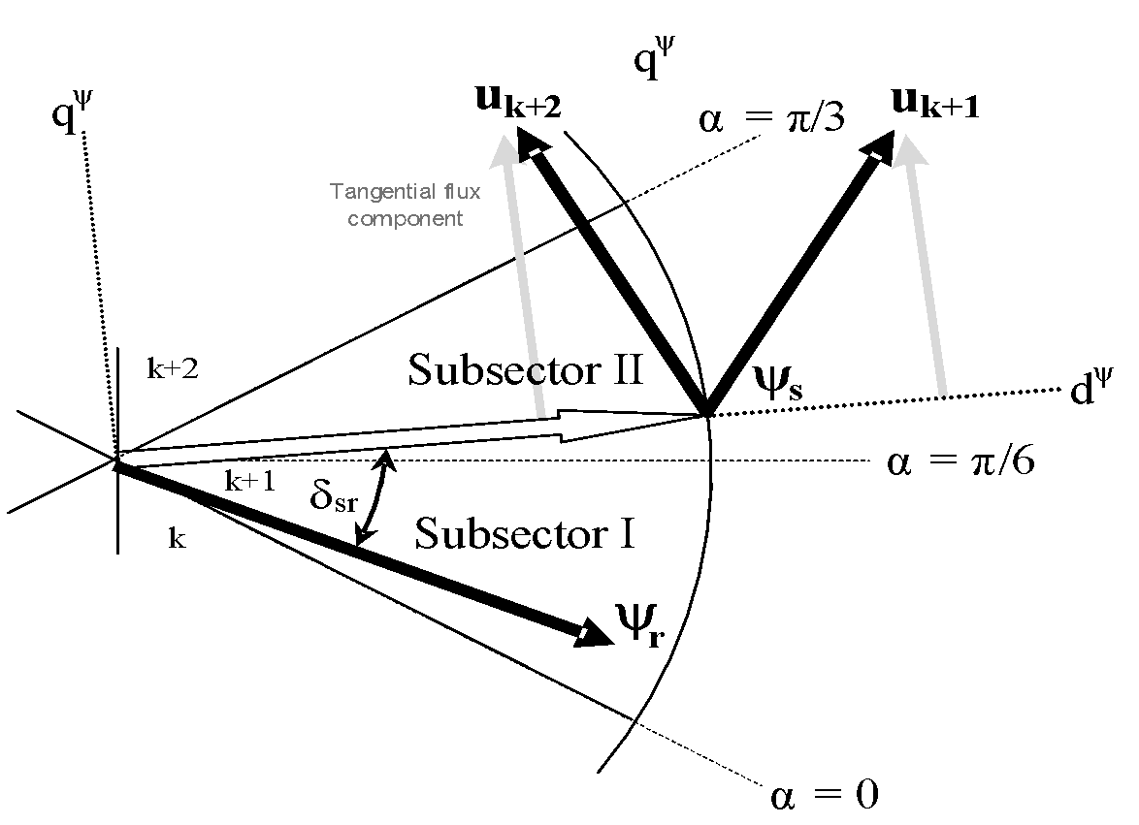  Figure 1. Effects of selecting different switching under dynamic condition

3. Results and Analysis
In this section, it is explained the results of research and at the same time is given the comprehensive discussion. Results can be presented in figures, graphs, tables and others that make the reader understand easily [2], [5]. The discussion can be made in several sub-chapters.

3.1. Equation
The equations are an exception to the prescribed specifications of this template. You will need to determine whether or not your equation should be typed using either the Times New Roman or the Symbol font (please no other font). To create multileveled equations, it may be necessary to treat the equation as a graphic and insert it into the text after your paper is styled.
Number equations consecutively. Equation numbers, within parentheses, are to position flush right, as in (1), using a right tab stop. To make your equations more compact, you may use the solidus ( / ), the exp function, or appropriate exponents. Italicize Roman symbols for quantities and variables, but not Greek symbols. Use a long dash rather than a hyphen for a minus sign. Punctuate equations with commas or periods when they are part of a sentence, as in
⟨ + ® = © (1)
Note that the equation is centered using a center tab stop. Be sure that the symbols in your equation have been defined before or immediately following the equation. Use “(1),” not “Eq. (1)” or “equation (1),” except at the beginning of a sentence: “Equation (1) is ...”

3.2. Sub Bab 2
Yy

4. Conclusion
Provide a statement that what is expected, as stated in the "Introduction" chapter can ultimately result in "Results and Discussion" chapter, so there is compatibility. Moreover, it can also be added the prospect of the development of research results and application prospects of further studies into the next (based on result and discussion).

Acknowledgment
The preferred spelling of the word “acknowledgment” in America is without an “e” after the “g.” Avoid the stilted expression “one of us (R. B. G.) thanks ...”. Instead, try “R. B. G. thanks...”. Put sponsor acknowledgments in the unnumbered footnote on the first page.

References
The main references are international journals and proceeding. All references should be to the most pertinent and up-to-date sources. References are written in Vancouver style. Each citation should be written in the order of appearance in the text. Please use a consistent format for references – see examples below:

If your references are from journal artilces:
- Author1 A, Author2 B. Title of Manuscript. Name of Journal or its Abbreviation. year; Vol.(Issue): pages.
- Casadei D, Serra G, Tani K. Implementation of a Direct Control Algorithm for Induction Motors Based on Discrete Space Vector Modulation. IEEE Transactions on Power Electronics. 2007; 15(4): 769-777. (in this case Vol.15, Issues 4, and page 769-777)

If your references are from Proceeding artilces:
If the proceedings consists of several volumes
- Author1 A, Author2 B. Title of Manuscript. Name of Conference of Seminar. City. Year; volume: pages.
- Calero C, Piatiini M, Pascual C, Serrano MA. Towards Data Warehouse Quality Metrics. Proceedings of the 3rd Intl. Workshop on Design and Management of Data Warehouses (DMDW). Interlaken. 2009; 39: 2-11. (in this case, city: Interlaken, year: 2009, Vol.39, page: 2-11)

If the proceedings in single volume
- Author1 A, Author2 B. Title of Manuscript. Name of Conference or Seminar. City. year: pages.
- Yamin L, Wanming C. Implementation of Single Precision Floating Point Square Root on FPGAs. IEEE Symposium on FPGA for Custom Computing Machines. Napa. 2008: 226-232.

If your references are from Texbooks:
If the references are refer to specific page range in a book
- Author1 A, Author2 B. The Title of the Book. Edition. City: Publishert. year: pages.
- Mohan N, Undeland TM, Robbins WP. Power Electronics. New York: John Wiley & Sons. 2005: 11-13.
- Ward J, Peppard J. Strategic planning for Information Systems. Fourth Edition. West Susse: John Willey & Sons Ltd. 2007: 102-104.

If the references are refer to some separate pages in a book.
- Author1 A, Author2 B. Judul Buku. City: Publisher. Year.
- Mohan N, Undeland TM, Robbins WP. Power Electronics. New York: John Wiley & Sons. 2005.
- Ward J, Peppard J. Strategic planning for Information Systems. Fourth Edition. West Susse: John Willey & Sons Ltd. 2007.

Edited book:
- Author1 A, Author2 B. Editors. Title of the Book. City: Publisher. Year.
- Zade F, Talenta A. Editors. Advanced Fuzzy Control System. Yogyakarta: UAD Press. 2010.

Chapter in a book:
- Author1 A, Author2 B. Title of the Book. In: Editor1 A, Editor2, B. Title of the Book. Edition. City: Publisher. Year: pages.
- Arkanuddin M, Fadlil A, Sutikno T. A Neuro-Fuzzy Control for Robotic Application Based on Microcontroller. In: Krishnan R, Blaabjerg F. Editors. Advanced Control for Industrial Application. 2nd ed. London: Academic Press; 2006: 165-178.

Translated Books.
- Originil Author. Year. Title of the Translated Book. Translater. City: Publisher of the translated book. Year of the translated book.
- Pabla. 2004. Sistem Distribusi Tenaga Listik. Abdul Hadi. Jakarta: Erlangga. 2007.

If your references are from Thesis/Disertation:
- Author. Title of Thesis/Disertation. Thesis/Disertation. City & Name of University/Institute/College; Year.
- Rusdi M. A Novel Fuzzy ARMA Model for Rain Prediction in Surabaya. PhD Thesis. Surabaya: Postgraduate ITS; 2009.

If your references are from Paten:
- Author1 A, Author2 B.. Title (this should be in italics). Patent number (Patent). Year of publication.
- Ahmad LP, Hooper A. The Lower Switching Losses Method of Space Vector Modulation. CN103045489 (Patent). 2007.

If your references are from Standards:
- Name of Standard Body/Institution. Standard number. Title (this should be in italics). Place of publication. Publisher. Year of publication.
- IEEE Standards Association. 1076.3-2009. IEEE Standard VHDL Synthesis Packages. New York: IEEE Press; 2009.

If your references are from Reports
- Author/Editor (if it is an editor/editors always put (ed./eds.) after the name). Title (this should be in italics). Organisation. Report number: (this should be followed by the actual number in figures). Year of publication.
- James S, Whales D. The Framework of Electronic Goverment. U.S. Dept. of Information Technology. Report number: 63. 2005.

Internet:
Avoid wherever possible

Note:
Please be sure to check for spelling and grammar before submitting your paper.

