The title should be no more than 15 words, concise, and informative, accurate description of the contents

(TNR, Center, 20pt)

First Author^{1*}, Second Author², Third Author³ (TNR, Bold, 10 pt)
^{1,2}Department of Electrical Engineering, UIN Sunan Gunung Djati Bandung, Indonesia (10 pt)
³Department of Informatics, UIN Sunan Gunung Djati Bandung, Indonesia (10 pt)
email1@email.com¹, email2@email.com², email3@email.com³

Article Info |  | ABSTRACT (10 PT)
Article history:  Received: #  Revised: #  Accepted: #  Published: # |  | A well-prepared abstract enables the reader to identify the basic content of a document quickly and accurately, to determine its relevance to their interests, and thus to decide whether to read the document in its entirety. The Abstract should be informative and completely self-explanatory, provide a clear statement of the problem, the proposed approach or solution, and point out major findings and conclusions. The Abstract should be 150 to 250 words in length. The abstract should be written in the past tense. Standard nomenclature should be used and abbreviations should be avoided. No literature should be cited. The keyword list provides the opportunity to add keywords, used by the indexing and abstracting services, in addition to those already present in the title. Standard nomenclature should be used, and non-standard or uncommon abbreviations should be avoided, but if essential they must be defined at their first mention in the abstract itself. No literature should be cited. The keyword list provides the opportunity to add 3 to 6 keywords, used by the indexing and abstracting services, in addition to those already present in the title (10 pt).
Keywords:
First keyword;
Second keyword;
Third keyword;
Fourth keyword;
Fifth keyword.
*(not more than 5)
Corresponding Author:
Name of Corresponding Author,
Affiliation of Corresponding Author
Email Corresponding Author.

INTRODUCTION (11 PT)
The introduction contains the background to the problem, previous research or state of the art related to the research being conducted, any research gaps/differences between the research conducted and previous research that serve as contributions to the research, and clear and specific research objectives. Articles designated as state of the art are articles published within the last five years, originating from journals or proceedings [1], [2]. The introduction is written as a single chapter without subheadings. All presentations in this chapter are written in essay form, so there is no numerical or alphabetical format separating chapters/sections or marking new chapters/sections. Therefore, if any part of the article requires numbering or bullet lists, create them in flowing paragraphs as follows: 1) one; 2) two; and 3) three. The article is the author's original work and has never been published elsewhere. The article title should be as few words as possible to adequately summarize the subject. The title should be no more than 15 words, concise, and informative. A full article follows a standard structure: 1. Introduction, 2. The Comprehensive Theoretical Basis and/or the Proposed Method/Algorithm (optional), 3. Method, 4. Results and Discussion, and 5. Conclusion. The structure is well-known as IMRaD style.

METHOD (11 PT)
This section describes the research stages, including the research design, research procedures (in the form of algorithms, pseudocode, or other), testing methods, and data acquisition [1], [3]. The description of the research process must be supported by references to ensure scientifically sound explanations [2], [4]. If necessary, this chapter can be broken down into several subchapters. This section can include subchapters containing theoretical studies related to the research.

- Writing Rules
The manuscript is typed using a computer in MS Word format, on A4 paper, single-spaced with 3-3-3-3 margins, and written close together left and right (justify). The font used is Times New Roman (TNR) for all styles with size 11, except for image captions and tables with size 10. The number of pages is between 7 - 15 pages. The manuscript is written in English [3]. The writing refers to the structure of scientific writing, with clear and not too long sentences. The beginning of each paragraph is indented by 0.75 cm. If there is something that must be listed, then the list is made in lowercase letters. If another list is needed, it is not written in a list format, but is made into a flowing paragraph as follows: 1) one; 2) two; and 3) three. The distance between sub-chapters is 1 space (one ENTER key).

2.1.1 Content of the Manuscript
Manuscripts should be written concisely. Discussions of well-known theories should be avoided. Manuscripts consist of three parts:
  - The initial section consists of the title, author's name (without title), institution of employment, email address, abstract, and keywords. If there is more than one author, the authors' names are listed sequentially, with the main author's name listed first. Corresponding authors are marked with an asterisk after their name.
  - The main section should consist of four chapters: introduction, research methods, results and discussion, and conclusion. If necessary, the Research Methods and Results and Discussion chapters can be broken down into several subchapters.
  - The closing section contains Acknowledgments (if any) and References.
Subchapters should only be written up to heading 3. If additional explanation is needed, it can be written in heading 4, but not in numbers, but in capital letters.
- Sub-Chapter Level 4
Chapters and subchapters are all left-aligned. Chapters and subchapters are capitalized at the beginning of every word, except conjunctions and prepositions.
- Sub-Chapter Level 4
Lorem ipsum

RESULT AND DISCUSSION (10 PT)
This section describes the research results and provides a comprehensive discussion. The results can be presented in figures, graphs, tables, and other formats to make them easier for the reader to understand [2], [5]. If the author is designing a prototype or tool, this chapter can begin with the design stage. The discussion can be divided into several sub-chapters.

  - Figures and Tables
Manuscripts may include tables, graphs, images, and photographs. Tables, graphs, images, and photographs must be given a brief and clear title, and each must be given a sequential number appropriate to the content of the manuscript. Figures and tables are numbered sequentially starting from number 1. Numbering does not use chapter numbering. Text in tables is size 9 or 10, depending on the size of the table. Each figure and table caption must end with a period. Figure or table captions begin with a capital letter at the beginning of the sentence only, then use lowercase letters, except for names and abbreviations. The text in the figure must be clear and legible. Tables are sufficient with horizontal lines in the header and closing section. If the table continues on the next page, the table header must still appear. Tables must not be cropped from other manuscripts, must be rewritten. Figures and tables must be called/mentioned in the manuscript. If the Figure and Table are not your own work, then the source must be listed. Writing the source is done by citing the Figure and Table when the Figure and Table are mentioned in the manuscript. Figures and Tables are placed in the center. The following are examples of Figures and Tables.
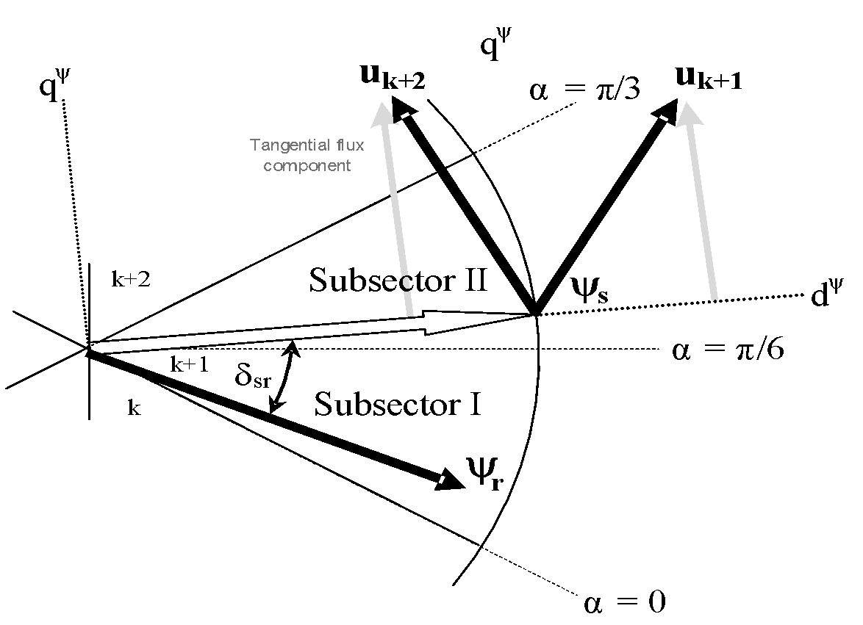
Figure 1. Effect of selecting different switching methods under dynamic conditions.

Table 1. System performance.
Variable | Speed (rpm) | Power (kW)
X | 10 | 8.6
Y | 15 | 12.4
Z | 20 | 15.3

Figures with Figures or Figures with and Tables can be placed side by side.

Table 1. System performance. | Figure 1. Effect of selecting different switching methods under dynamic conditions.
  Variable | Speed (rpm) | Power (kW)
  X | 10 | 8.6
  Y | 15 | 12.4
  Z | 20 | 15.3

Equations
Equations are sequentially numbered in parentheses with right-aligned margins, as in (1). Use the equation editor to create the equation. Tabulate and write the equation number in parentheses. To make your equation more compact, use a forward slash (/), exponent, or exponent as appropriate. Use parentheses to avoid confusion when giving fractions. Explain the equation when it is part of a sentence, as follows.
(1)
Make sure that the symbols in the equation are defined before the equation or immediately after it appears. All variables/symbols are written in italics (T refers to temperature, but T is the unit Tesla). Refer to “(1)”, not “Equation (1)” or “equation (1)”, except at the beginning of a sentence: “Equation (1) is …”. Equations must be part of a sentence, not stand alone. If a sentence ends with an equation, then the end of the equation is ended by a period. If the equation is not the end of the sentence, then the equation is ended by a comma, and the sentence continues with the beginning of a lowercase letter. If there is more than one equation, then a colon is placed before it [12]:
$K_{p}=\frac{0,9T}{K.L}$ (2)
$T_{i}=3,33x L$. (3)

- CONCLUSION (11 PT)
Draw conclusions regarding the achievement of the objectives outlined in the Introduction. These conclusions should be presented in a narrative form, not as a list containing only numbers. Also, outline the development prospects for the research conducted.

ACKNOWLEDGEMENTS (11 PT)
This research was supported/partially supported by [Name of Foundation, Grant maker, Donor]. We thank our colleagues from [Name of the supporting institution] who provided insight and expertise that greatly assisted the research, although they may not agree with all of the interpretations/conclusions of this paper.

CONFLICT OF INTEREST (11 PT)
It should disclose any financial or non-financial interests such as political, personal, or professional relationships that may be interpreted as having influenced the manuscript. The phrase "The authors declare no conflicts of interest" should be included if there is no conflict of interest.

REFERENCES (11 PT)
The headings in the References section should not be numbered. All reference items should be in 11-point font. Use IEEE Style. References in the form of journal articles should be published no more than 5 years previously. The first step in the citation process occurs within the manuscript itself. Each citation should be noted in the text through the use of a simple sequential number. Reference items are numbered sequentially within square brackets (e.g., [1]). A number enclosed in square brackets, placed in the text of the report, indicates the specific reference. Citations are numbered in the order they appear. Once a source is cited, the same number can be used in all subsequent references in the manuscript. Citations and references should be written using a reference manager, such as Mendeley, Zotero, or at least a Microsoft Word reference manager.
When referring to a reference item, please use only the reference number, for example, [2]. Do not use "Ref. [3]" or "Reference [3]" except at the beginning of a sentence, e.g., "Reference [3] shows that...". When using multiple references, each number is typed in separate brackets (e.g., [2], [3], [4 - 6]).
Some other examples of how to cite in a manuscript:
“. . . end of line for my research [13].”
“This theory was first proposed in 1987 [1].”
“Scholtz [2] argues. . . ”
“For example, see [7].”
“Several recent studies [3, 4, 15, 22] have suggested that. . . ”

Note: The author and date do not have to be listed after the first reference; use parenthetical numbers. Also, there is no need to write “in references [2].” Simply write “in [2].”
The preferred method for citing more than one source at a time is to list each reference in parentheses, then separate them with commas or hyphens:
[1], [3], [5]
[1 - 5]

The rules for writing references are as follows:

ELECTRONIC DOCUMENTS

E-books
- L. Bass, P. Clements, and R. Kazman, Software Architecture in Practice, 2nd ed. Reading, MA: Addison Wesley, 2003. [E-book] Available: Safari e-book.

Article in Online Encyclopedia
- D. Ince, “Acoustic coupler,” in A Dictionary of the Internet. Oxford University Press, [online document ], 2001. Available: Oxford Reference Online, http://www.oxfordreference.com [Accessed: May 24, 2007].

Journal Article Abstract (accessed from online database)
- M. T. Kimour and D. Meslati, “Deriving objects from use cases in real-time embedded systems,” Information and Software Technology, vol. 47, no. 8, p. 533, June 2005. [Abstract]. Ava ilable: ProQuest, http://www.umi.com/proquest/. [Accessed November 12, 2007].

Journal Article in Scholarly Journal (published free of charge on the Internet)
- A. Altun, “Understanding hypertext in the context of reading on the web: Language learners’ experience,” Current Issues in Education, vol. 6, no. 12, July, 2005. [Online serial]. Available: http://cie.ed.asu.edu/volume6/number12/. [Accessed Dec. 2, 2007].

Newspaper Article from the Internet
- C. Wilson-Clark, “Computers ranked as key literacy,” The Atlanta Journal Constitution, para. 3, March 29, 2007. [Online], Available: http://www.thewest.com.au. [Accessed Sept. 18, 2007]

INTERNET DOCUMENTS

Professional Internet Site
- European Telecommunications Standards Institute, “Digital Video Broadcasting (DVB): Implementation guide for DVB terrestrial services; transmission aspects,” European Telecommunications Standards Institute, ETSI-TR-101, 2007. [Online]. Available: http://www.etsi.org. [Accessed: Nov. 12, 2007].

General Internet Site
- J. Geralds, “Sega Ends Production of Dreamcast,” vnunet.com, para. 2, Jan. 31, 2007. [Online]. Available: http://nli.vnunet.com/news/1116995. [Accessed Sept. 12, 2007].

Personal Internet Site
- G. Sussman, “Home Page-Dr. Gerald Sussman,” July, 2002. [Online]. Available : http://www.comm.edu.faculty/sussman/sussmanpage.htm. [Accessed Nov. 14, 2007].

Email
- J. Aston. “RE: new location, okay?” Personal email (July 3, 2007).

Internet Newsgroup
- G. G. Gavin, “Climbing and limb torsion #3387,” USENET: sci.climb.torsion, August 19, 2007. [Accessed December 4, 2007].

Microform
- W. D. Scott, Information Technology in the US. [Microform]. W. D. Scott & Co., Canberra: Department of Science and Technology, 2004.

Computer Game
- The Hobbit: The prelude to the Lord of the Rings. [CD-ROM]. United Kingdom: Vivendi Universal Games, 2003.

Software
- Thomson ISI, Endnote 7. [CD-ROM]. Berkeley, CA: ISI ResearchSoft, 2006.

Lecture
[1] S. Bhanndahar. ECE 4321. Class Lecture, Topic: “Bluetooth can’t help you.” School of Electrical and Computer Engineering, Georgia Institute of Technology, Atlanta, GA, Jan. 9, 2008

PRINT DOCUMENTS

Books
Single Author
- W. K. Chen, Linear Networks and Systems. Belmont, CA: Wadsworth Press, 2003.

Edited Book
- J. L. Spudich and B. H. Satir, Eds., Sensory Receptors and Signal Transduction. New York: Wiley-Liss, 2001.

Selection in an Edited Book
- E. D. Lipson and B. D. Horwitz, “Photosensory reception and transduction,” in Sensory Receptors and Signal Transduction, J. L. Spudich and B. H. Satir, Eds. New York: Wiley-Liss, 2001, pp-1-64.

Three or More Authors
- R. Hayes, G. Pisano, and S. Wheelwright, Operations, Strategy, and Technical Knowledge. Hoboken, NJ: Wiley, 2007.

Book by an Institutional or Organizational Author
- Council of Biology Editors, Scientific Style and Format: The CBE Manual for Authors, Editors, and Publishers, 6th ed., Chicago: Cambridge University Press, 2006.

Manual
- Bell Telephone Laboratories Technical Staff, Transmission System for Communication, Bell Telephone Lab, 2005.

Application Note
- Hewlett-Packard, Appl. Note 935, pp.25-29.

Note: Titles of unpublished works are not italicized or capitalized. Capitalize only the first word.

Technical Report
- K. E. Elliott and C. M. Greene, “A local adaptive protocol,” Argonne National Laboratory, Argonne, France, Tech. Report. 916-1010-BB, 7 Apr. 2007.

Patent /Standard
- K. Kimura and A. Lipeles, “Fuzzy controller component,” U. S. Patent 14, 860,040, 14 Dec., 2006.

Data Sheet
- Texas Instruments, “High speed CMOS logic analog multiplexers/demultiplexers,” 74HC4051 datasheet, Nov. 1997 [Revised Sept. 2002].

Government Publication
- National Aeronautics and Space Administration, NASA Pocket Statistics. Washington, DC: Office of Headquarters Operations, 2007.

Paper Published in Conference Proceedings
- J. Smith, R. Jones, and K. Trello, “Adaptive filtering in data communications with self improved error reference,” In Proc. IEEE International Conference on Wireless Communications ’04, 2004, pp. 65-68.

Papers Presented at Conferences (unpublished)
- H. A. Nimr, “Defuzzification of the outputs of fuzzy controllers,” presented at 5th
International Conference on Fuzzy Systems, Cairo, Egypt, 2006.

Thesis or Dissertation (unpublished)
- H. Zhang, “Delay- insensitive networks,” M. S. thesis, University of Chicago, Chicago, IL, 2007.

Article in Encyclopedia, Signed
- O. Singh, “Computer graphics,” in McGraw-Hill Encyclopedia of Science and Technology, New York: McGraw-Hill, 2007, pp. 279-291.

JOURNAL ARTICLES

Article in Journal (paginated by annual volume)
- K. A. Nelson, R. J. Davis, D. R. Lutz, and W. Smith, “Optical generation of tunable ultrasonic waves,” Journal of Applied Physics, vol. 53, no. 2, Feb., pp. 1144-1149, 2002.

Article in Professional Journal (paginated by issue)
- J. Attapangittya, “Social studies in gibberish,” Quarterly Review of Doublespeak, vol. 20, no. 1, pp. 9-10, 2003.

Article in Monthly or Bimonthly Periodical
- J. Fallows, “Networking technology,” Atlantic Monthly, Jul., pp. 34-36, 2007.

Article in Daily, Weekly, or Biweekly Newspaper or Magazine
- B. Metcalfe, “The numbers show how slowly the Internet runs today,” Infoworld, 30 Sep., p. 34, 2006

